Analysis of Removal of Individual Species

These plots were produced from the following scripts located in this directory: C:\Users\wraseman\Hazen and Sawyer\Stanford, Benjamin - Loxahatchee DBF Evaluation\Data Analysis - Billy\R

* 03_viz_pct-rmv_ind-params.R

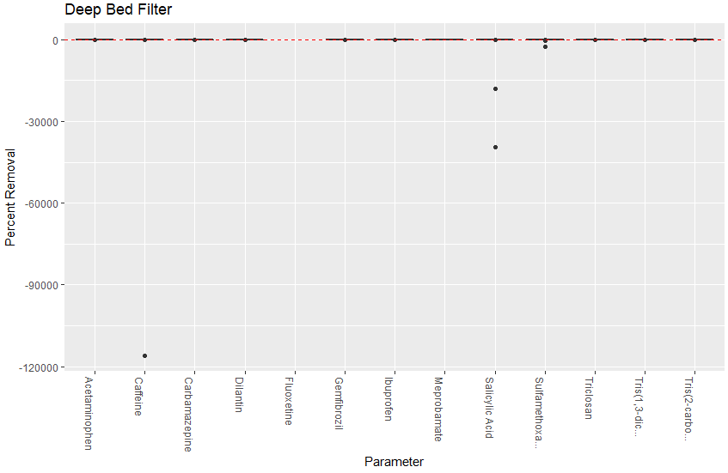

Each of these values correspond to non-detects in the filter influent and detectable levels of CECs in filter effluent

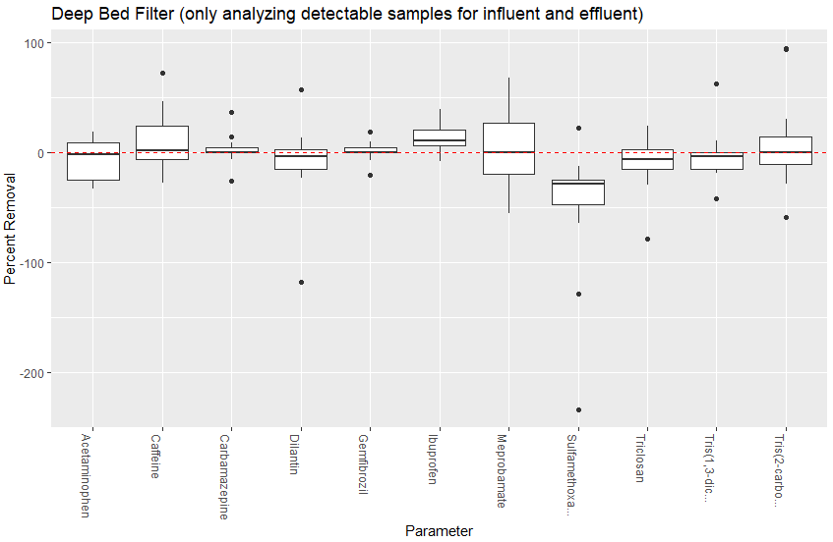

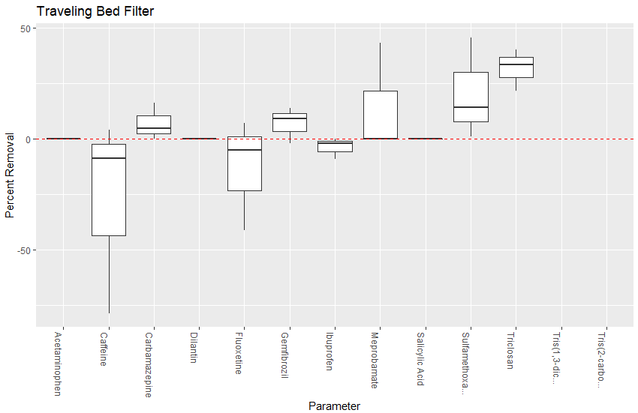

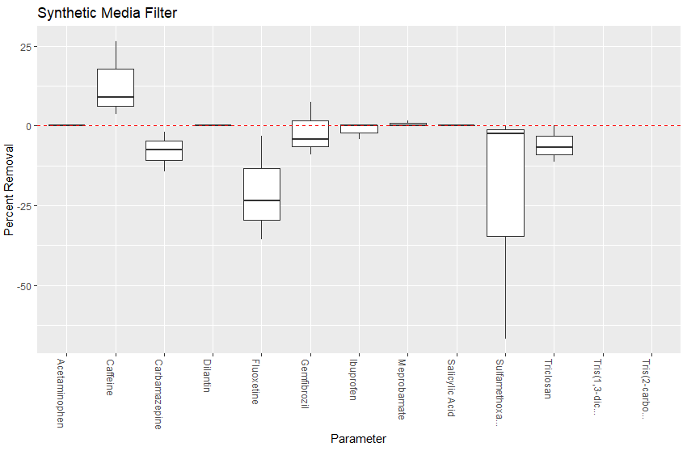

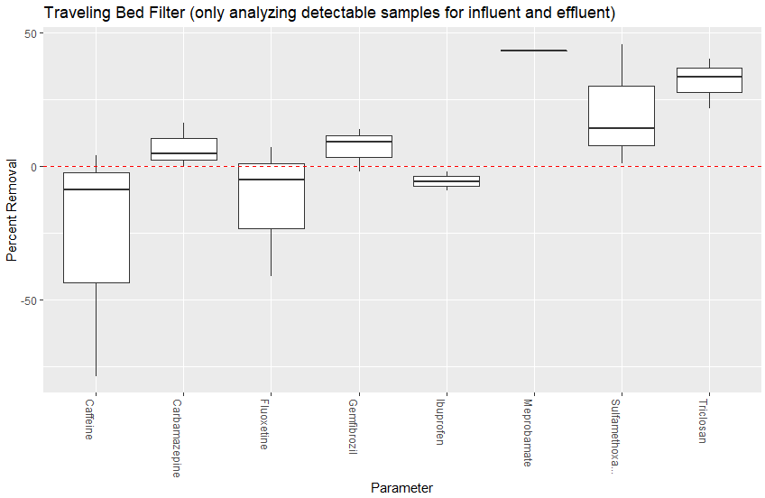

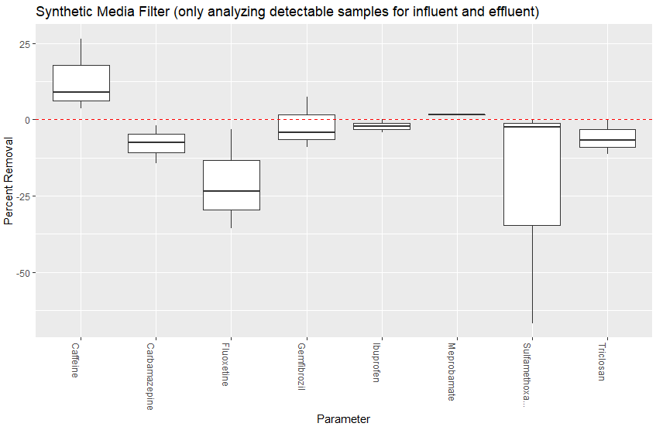

# Time Series Analysis

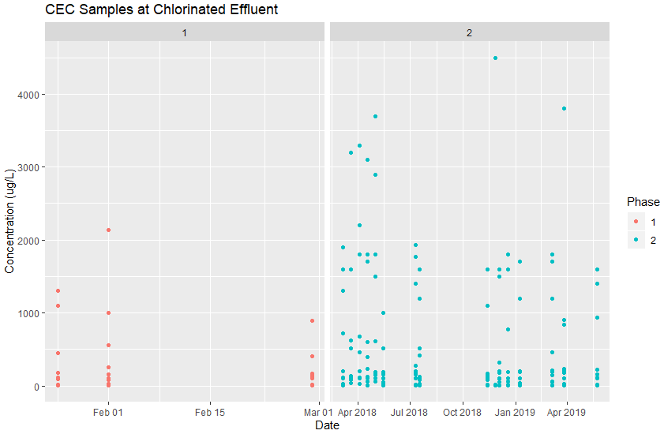

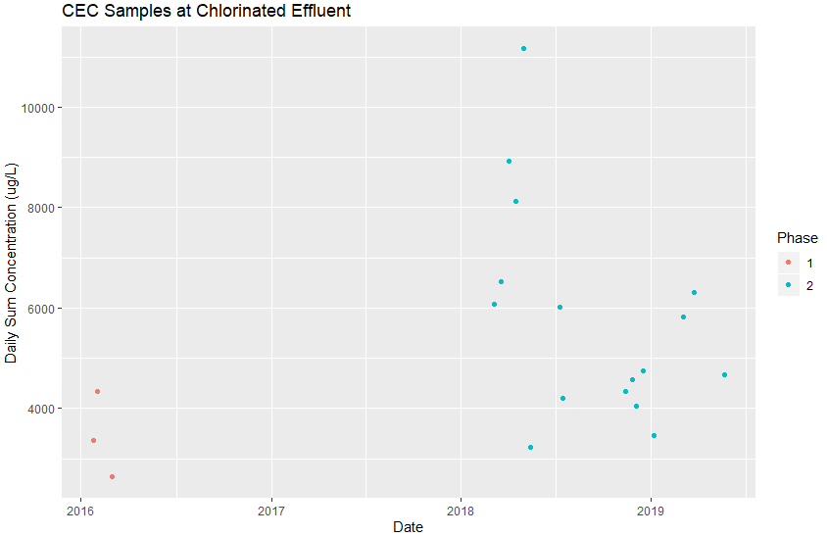  
Parameters analyzed: Acetaminophen, Caffeine, Carbamazepine, Dilantin, Gemfibrozil, Ibuprofen, Meprobamate, Salicylic Acid, Sulfamethoxazole, Triclosan